SE322 - Software Architecture

Project - Phase 2

2021-22 Spring

**HealEye**

**Artichokes**

05.05.2022

Table of Contents

1. The Health Monitoring System

1.1 The system in a nutshell

1.2 Views

1.2.1 Module View

1.2.2 C&C View

1.2.3 Allocation View

1.3 Architectural Diagrams by OSATE

2. Github Repo

3. Discussion

1. **The Health Monitoring System**

## **The system in a nutshell**

**HealEye**

Based on data collected from wearable sensors, the health monitoring system monitors and acts on the patient's health at home. The patient's situation could be critical, unstable, or ordinary. An emergency is a situation that necessitates quick medical intervention. It denotes a circumstance in which the insecure health monitoring system is unable to reach a firm judgment, and medical personnel is needed to aid in assessing the patient's status. It usually means that the patient's medical indications, such as stress, are within normal levels and that no further action is necessary. Sensors measure the patient's heart rate, oxygen saturation, breathing, electrocardiography, blood pressure, body temperature, and position. (Is it falling or still resting?)The sensor sends data to a device at home, which acts as a conduit between the in-house Bluetooth and the sensors. This gadget can also connect to the cloud, allowing data to be securely saved. The patient's and their relatives’ names, last name, history, diseases, operations where he has allergies; doctor's name and plastered doctor's name last name telephone number email address and the name of the hospital he works for are among the data in the recorded data. Each patient's data is stored in the cloud, and it can be accessed over the internet. The physician who uses this system keeps track of the patient's progress and records notes. The patient who grants access to this system keeps an eye on the patient and does not always come to the hospital to swarm them, but instead maintains a quiet atmosphere. Certain steps are followed if the patient's condition returns to the emergency room. The operation will continue if the patient's condition is normal. The proper procedure is used if the patient's situation is not favorable.

## **1.2 Views**

### **1.2.1 Module View**

*Provide a module decomposition diagram for the whole system.*

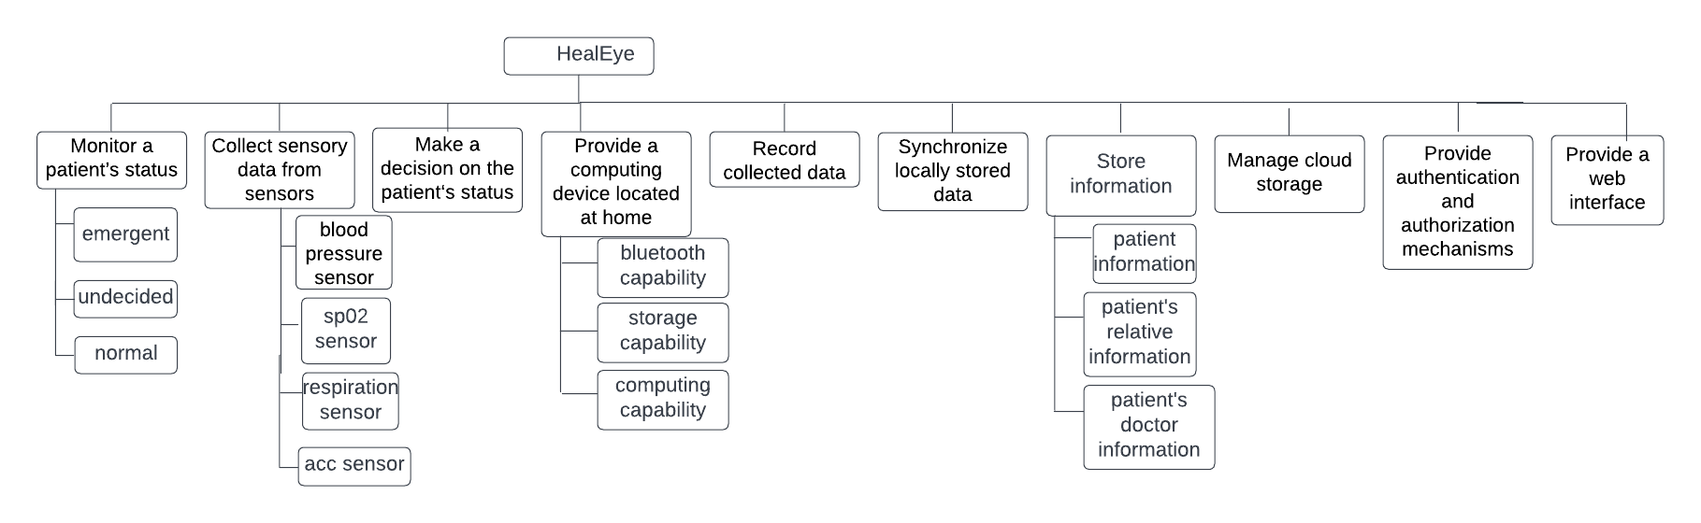

### **1.2.2 C&C View**

*Provide a set of activity diagrams to represent how the system works.*

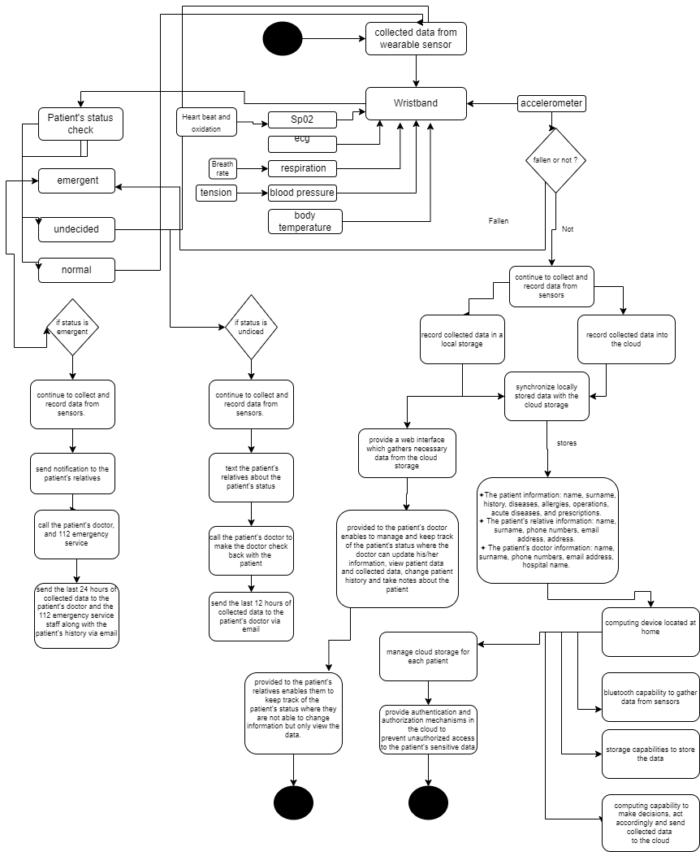

### **1.2.3 Allocation View**

*Provide a deployment diagram for the whole system.*

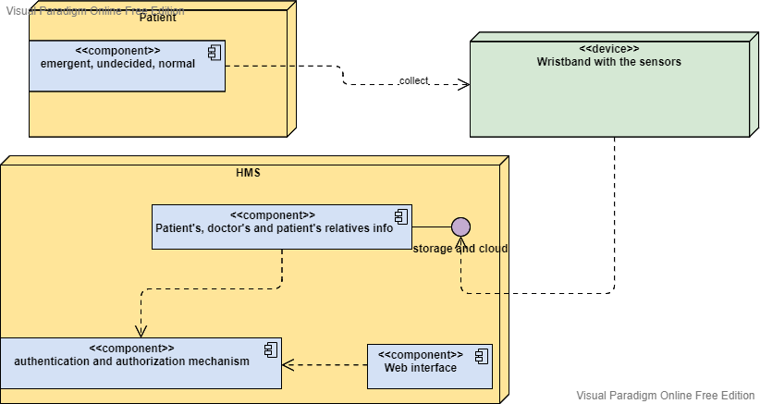

## **1.3 Architectural Diagrams by OSATE**

*Provide necessary architectural diagrams created automatically by the OSATE tool including components (systems, processes, threads, devices, busses, etc) for the system.*

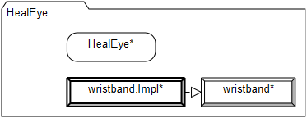

*hocam maalesef bu kadar yapabildik, kusura bakmayın.*

1. **Github Repo**

**https://github.com/goksunb/SE322-artichokes**

1. **Discussion**

The need for the patient to understand if they should fall is not based on scientific data, because the heartbeat of a fallen person rises, fears, and accelerates breathing. But these findings are the same with a running person, which would be very difficult to spot the patient who will fall as he moves quickly, however beautiful and life-saving, we haven't been able to really look at his place in our system.

If there are no security measures in the cloud to store the data of each patient, it is a serious vulnerability, because we are holding all the data of the doctor in the cloud to the patient and their relatives at the same time. Unless there is a security concern, we think that keeping it limited to the patient will save both memory and expense, patient relative information is unnecessary.

How healthy is it for the patient to be on the web to monitor the patient at all times? Normally, a doctor walks through hospitals, gives information about the patient, and says, "You have nothing to do here." he'll send it home because it won't be crowded in the hospital. The biggest increase in this surveillance is definitely for hospital employees. We're leaving them a calmer, cleaner environment, and their lives are not at risk. We think the adverse effect is that if the patient is in bed or in a coma, it can be mentally corrosive that I don't watch the patient's patient and see that there is a change.

The backup time is 8 minutes, which is alarming for a heart attack patient. When the first 20 minutes of a heart attack are crucial and the ambulance arrives in Ankara in 15 minutes, we're losing a patient who has a heart attack while backing up, and maybe a procedure can be considered for this process.